*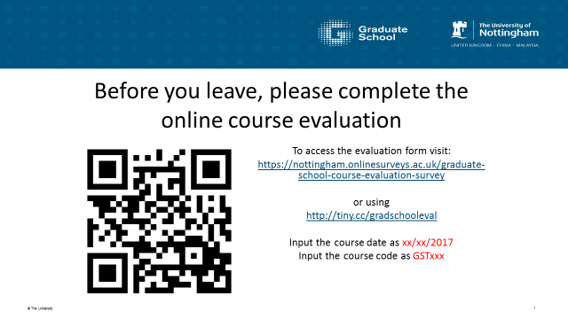*

*The students will now be required to input the date of the course and the course code separately. We are not going to use the 3 digit tutor code as part of the course details as this information can be added later by Graduate School staff. If you have any questions regarding the new survey please email* [*charlotte.lloyd@nottingham.ac.uk*](mailto:charlotte.lloyd@nottingham.ac.uk)*.*